**Azure Consumption**

**Guidelines**

**V1.0**

**Document Details**

|  |  |  |  |  |
| --- | --- | --- | --- | --- |
| **Created:** 8/30/18 | | | | |
| **Last Modified:** | | | | |
|  | | | | |
| **Version History:** | | | | |
| **Version No.** | **Date:** | **Updated By** | **Revised & Approved by** | **Description** |
| V1.0 | 6/11/18 | Alberto Escoto | Ernesto Brizuela  Manuel Molina |  |
|  |  |  |  |  |

# **Objective**

Create an Azure governance guideline which would include the standards and policies necessary to optimize cost efficiency and allow capabilities to provide visibility over the services consumed which should be done before November 15 ,2018.

# **Scope**

## Success criteria

* Create a Guidelines for Subject Matter experts and Managers. The document will contain:
  + Hierarchy Definitions
  + Naming Conventions
  + Standards and Policies
  + Automation Scripts
* Define critical workloads or services for support scenarios
* Create a report for service usage and billing consumption

# **Roles and Responsibilities**

|  |  |
| --- | --- |
| Tasks | Responsible |
| Hierarchy Definition | Alberto Escoto |
| Naming Conventions | Subscription Mgmt Admins |
| Standard and Policies | Subscription Mgmt Admins |
| Automation Script | Subscription Mgmt Admins |
| Critical workload definition | Subscription Mgmt Admins |
| Consumption Report | SDM’s |

# **Communications Plan**

|  |  |  |  |  |
| --- | --- | --- | --- | --- |
| Informed | Recurrence | Responsible | Approves | Informed |
| Consumption Report | Weekly (Weekly Business Review) | Alberto Escoto | SDM’s | Service Admin Community |
| Project updates | Weekly | Alberto Escoto | SDM’s | Service Admin Community |

# **Stakeholders**

|  |  |  |
| --- | --- | --- |
| Name | Position | Role within Project |
| Alberto Escoto | SME | Project Manager |
| Ernesto Brizuela | SDM | Project Sponsor |
| Manuel Molina | Global Ops Manager | Project Sponsor |
| David Robles | SDM | Project Sponsor |
| Bosede Omolehinwa | SDM | Project Sponsor |
|  |  |  |
| Andres Garcia | Support Eng. | Trainer |
| Service Admin Community | SME’s | Subscription Mgmt Admins |

## Azure Subscription Hierarchy

This chart defines the shape and use of Azure services within Tek-Experts from a functional point of view. This will be used as a basis to understand how we can further adapt our consumption practices based on the changing requirements or each department, users, and finally subscriptions.

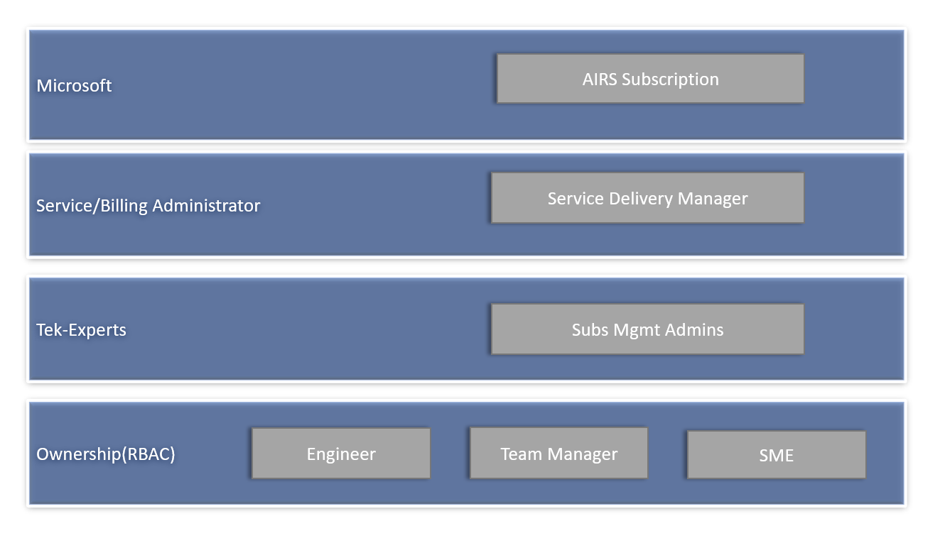

All subscriptions are created from an internal engine called AIRS. This subscription engine is being SDM’s created the accounts delegated to engineers. This account are linked to a Microsoft Cost Center, for that reason the SDM will remain to be the Service Administrator and Billing Administrator.

Moving forward engineers will be assigned as Co Administrator of their accounts. It is the responsibility of the support engineer to include to the subscription their SME and Team Manager. This would allow the organization to automate certain process to drive practices to reduce costs and implement best practices of deployment/configuration.

The Subscription Management Admininstrators will be be defined by the Operations Manager of each site. This role will be responsible to create the necessary actions to meet the consumption expectation of the customer(Microsoft/SDM).

To achieve this goal, the SDM’s of each region will provide a weekly report which would include the up to date cost for each subscription. At the end of every month there will be a report which would provide a breakdown of services, quotas, units and cost during a month per account.

The Subscription mgmt Admins will need to collectively improve the Azure Consumption guidelines to:

* Identity trend of services which increase costs
* Identity common deployment scenario for multiple teams.
* Drive the automation of common deployment services

## Naming Standards

Naming subscriptions

MAIC TEK Experts <Region> <Microsoft Alias>

* Region: NGA|COS|CR|BGR
* Microsoft Alias: This must be extracted from the Microsoft account example:
  + v-alesco
  + v-esbar
  + v-vibren

Support documentation

<https://docs.microsoft.com/en-us/azure/architecture/best-practices/naming-conventions>

## Policies

* Subscriptions with no managers included as co-owners.
* Subscriptions where owners are including other employees as owners.
* Subscriptions apparently changed in a way that are disappearing from my views.
* Subscriptions incorrectly used and setup for training purposes.
* Subscriptions put as available to activities related to Super Bench (This has not been approved by me to be done).

Super Bench is still not aligned with MS, so I am not creating Azure Subs. For super bench or approving their usage for this matter.

### Do’s

* The Team Manager and SME of the engineer should be included in the subscription ownership and Co-Administrator.

### Don’ts

* Other coworkers must not be included as owners at a subscription level
  + NOTE: Engineers can share resources using a Resource group and providing access on this level.
* Engineer must not share their subscription for training purposes. If so this should be communicated to the SME, T4 and Subscriptions Admins to provide visibility over the cost increase.
* New subscriptions approval must always be aligned with Operations Manager, SDM, Subscription Admins according to the New subscription process(TBD).

New subscription Request process

1. The Team manager should check first if there are no available subscription to transfer.
   1. NOTE: The Subscriptions will be tracked in the Global HeadTrax Form(TBD)
2. If no subscriptions are available, then an email should be send to the Subscription Admins (TBD)
   1. The Subscription Admins will notify the SDM on the new request and business need of the subscription. NOTE: (Subscription Admins will be trained in the process)
3. Subscription Admins will notify ones the subscription request is completed.

Transfer Subscription Ownership

If the Team manager/SME has subscription that are not used, they can change the ownership of the subscription

1. Access portal.azure.com
2. Login with the Microsoft account
3. Look for All Services
   1. 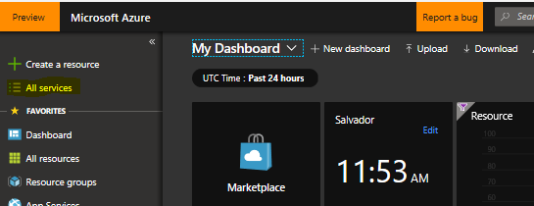
4. Search for Subscriptions
   1. 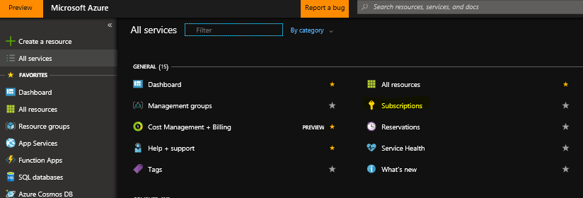
5. Search for the subscription that is not been used
   1. 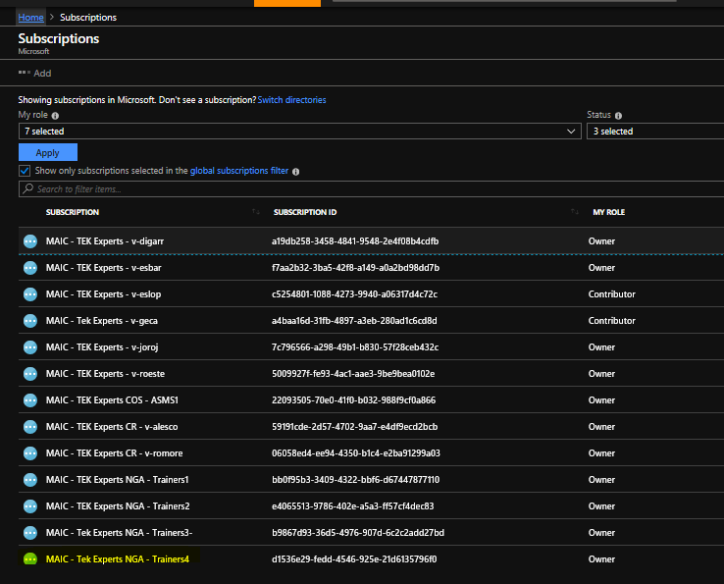
6. Click on the Subscription Name
7. Go to Access Control(IAM)
8. Remove the previous engineer and include the new owner
   1. NOTE: Do not remove the SDM, SME or Team Manager
9. Go back to the Overview of the subscription
10. Rename the Subscription according to the naming conventions
    1. NOTE: The naming convention of the subcriptions is:
       1. MAIC – TEK Experts <NGA|COS|CR|BGR> <Microsoft Alias>
       2. Example: MAIC - TEK Experts - v-esbar or MAIC - TEK Experts COS v-jogra
11. Update the Global HeadTrax Form
    1. NOTE: Please remove and leave blank the subscription field of the previous owner and update the current owner

## Critical Workloads

## High Consumption Services

## Automation Scripts

The automation scripts are used to drive the best practices to achieve certain reactive and proactive actions.

Reactive

Resource Deletion

In the scenarios in which the engineer has surpass the 400$ cost then follow these guidelines.

1. Check the subscription for possible reason of the increase in cost (Reference to High Consumption Services)
2. Document all services that are possible root cause and bad practices for later validation against the billing statement. (SP form TBD)
3. Execute the resource deletion script (Repository TBD)
   1. 

Proactive

VM auto Shutdown | Down Scaling

To be able to avoid deleting all resources from a subscription and reaching the 400$ mark then the following script will:

* TBD
* TBD

